**Search on homepage for any different term returns blank page with message “Unauthorized”**

**Used Device/Browser:**

* Chrome Version 104.0.5112.102 (Official Build) (64-bit) on Windows 10

**Steps to reproduce:**

* Open the <http://www.gatesnfences.com/index.html> page
* Click on Search Input Box
* Enter any term you wish to search for (E.g. gate openers)
* Click on the Search button or press Enter button on keyboard
* Blank page with “Unauthorized” message will be shown

**Screenshot:**

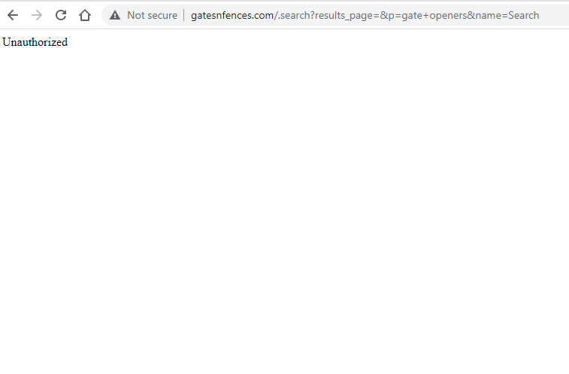

**Some images show cursor as links but lead nowhere**

**Used Device/Browser:**

* Chrome Version 104.0.5112.102 (Official Build) (64-bit) on Windows 10

**Steps to reproduce:**

* Open the <http://www.gatesnfences.com/index.html> page
* Hover with cursor over one of the images circled in the screenshot below
* In bottom left corner of the browser shows javascript:void(0)
* Click on one of the images
* Nothing happens

**Screenshot:**

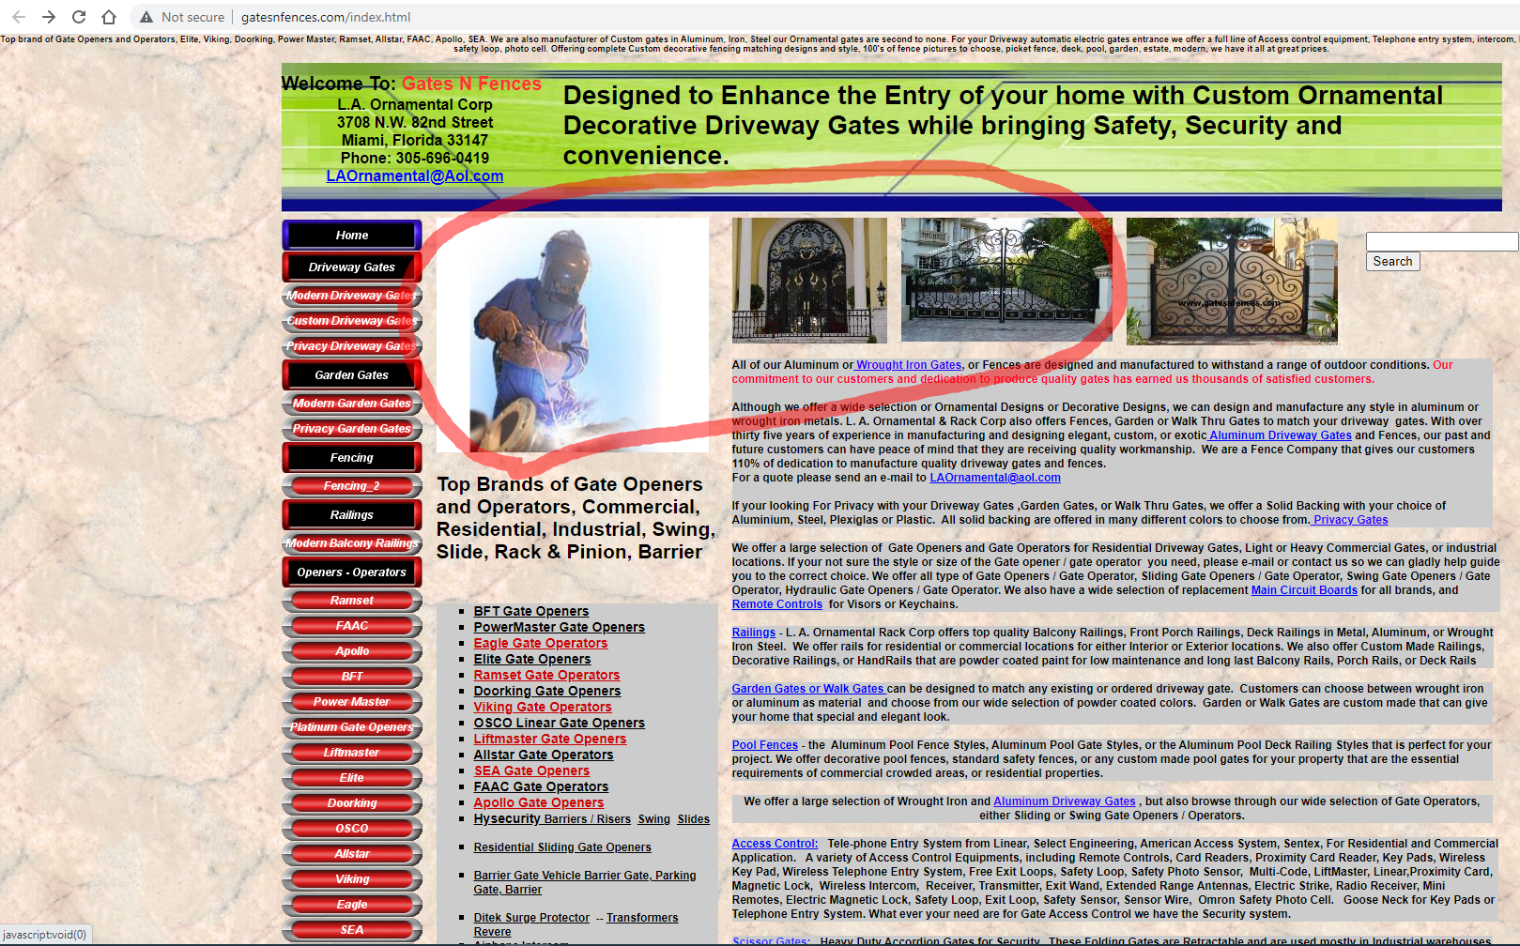

**Some images on main page have Copyright message upon cursor hover, some do not**

**Used Device/Browser:**

* Chrome Version 104.0.5112.102 (Official Build) (64-bit) on Windows 10

**Steps to reproduce:**

* Open the <http://www.gatesnfences.com/index.html> page
* Hover with cursor over one of the images on the main page of the website
* Some images change to display image with copyright message, some don’t change at all

**Screenshot:**

<https://screencast-o-matic.com/watch/c3jF6LVTXJL>

**Two images upon click open page in new tab, other images upon click take you to the page**

**Used Device/Browser:**

* Chrome Version 104.0.5112.102 (Official Build) (64-bit) on Windows 10

**Steps to reproduce:**

* Open the <http://www.gatesnfences.com/index.html> page
* Scroll down to images of different railings and gates
* Click on images circled yellow as shown on the screenshot below
* Page opens in new tab
* Close newly opened tab and return to main page
* Click on images circled red as shown on the screenshot below
* Upon click the link leads you to the new page in the same tab

**Screenshot:**

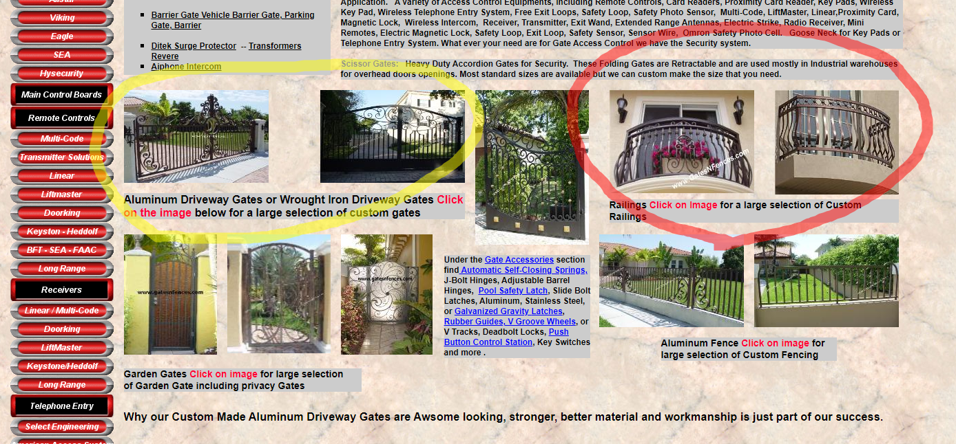

**Some links open in a new tab, some upon click take you to the page in the same tab**

**Used Device/Browser:**

* Chrome Version 104.0.5112.102 (Official Build) (64-bit) on Windows 10

**Steps to reproduce:**

* Open the <http://www.gatesnfences.com/index.html> page
* Click on link highlighted with yellow
* Page opens in new tab
* Close newly opened tab and return to main page
* Click on link highlighted with red
* Upon click the link leads you to the new page in the same tab

**Screenshot:**

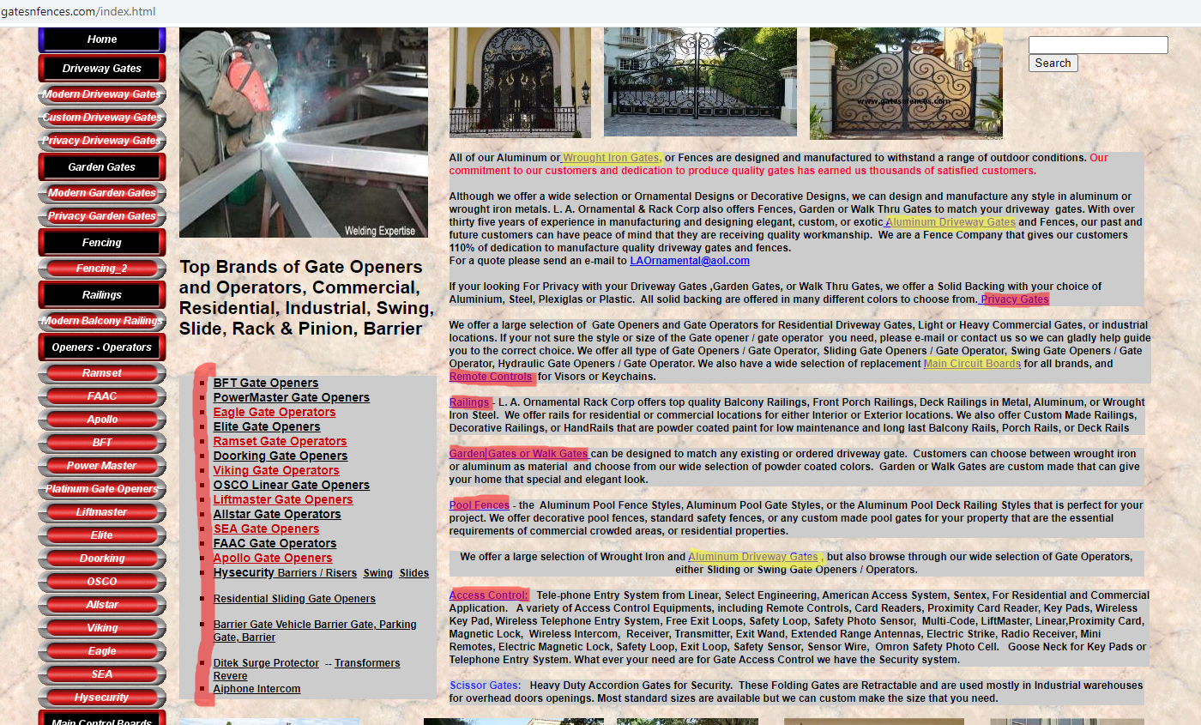

**‘Scissor Gates’ not a hyperlink and with that not clickable**

**Used Device/Browser:**

* Chrome Version 104.0.5112.102 (Official Build) (64-bit) on Windows 10

**Steps to reproduce:**

* Open the <http://www.gatesnfences.com/index.html> page
* Scroll down and place cursor over ‘Scissor Gates’ circled red as shown on screenshot below
* Cursor doesn’t show as hyperlink and it is not clickable

**Screenshot:**

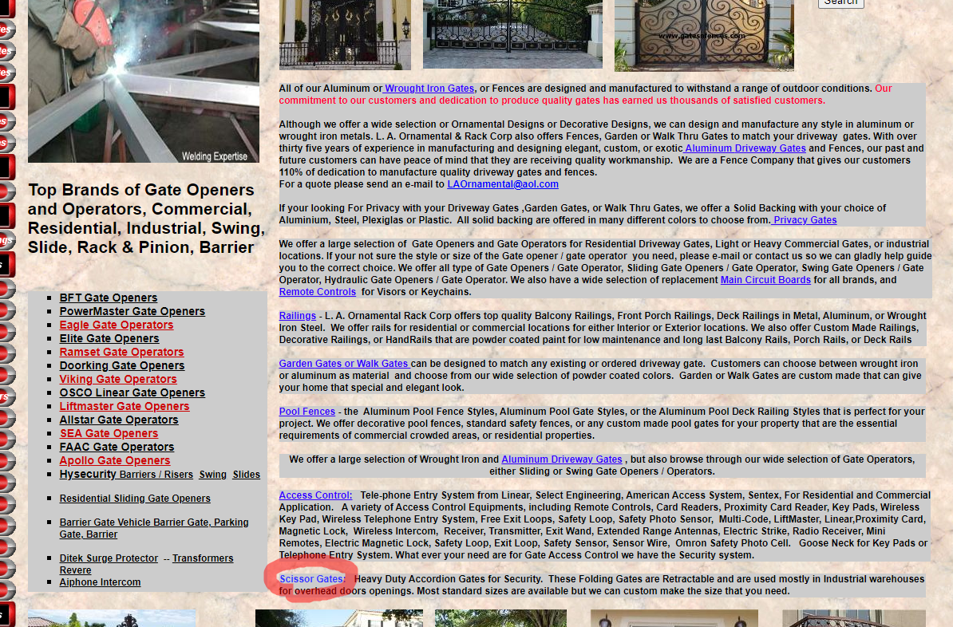

**Text overflows outside of button borders**

**Used Device/Browser:**

* Chrome Version 104.0.5112.102 (Official Build) (64-bit) on Windows 10

**Steps to reproduce:**

* Open the <http://www.gatesnfences.com/index.html> page
* Check the navigation bar on the left-hand side of the page
* Text of some buttons overflows over the border of the buttons

**Screenshot:**

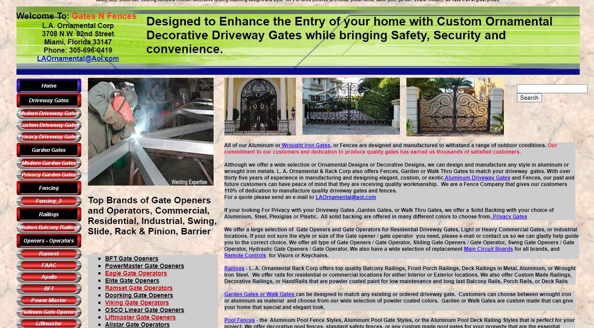

**Some elements fall out of the content wrapper**

**Used Device/Browser:**

* Chrome Version 104.0.5112.102 (Official Build) (64-bit) on Windows 10

**Steps to reproduce:**

* Open the <http://www.gatesnfences.com/index.html> page
* Check the alignment of the elements on the right-hand side of the page and the text in the top of the page
* Some elements don’t align with the rest of the content wrapper as show on the screenshot below

**Screenshot:**

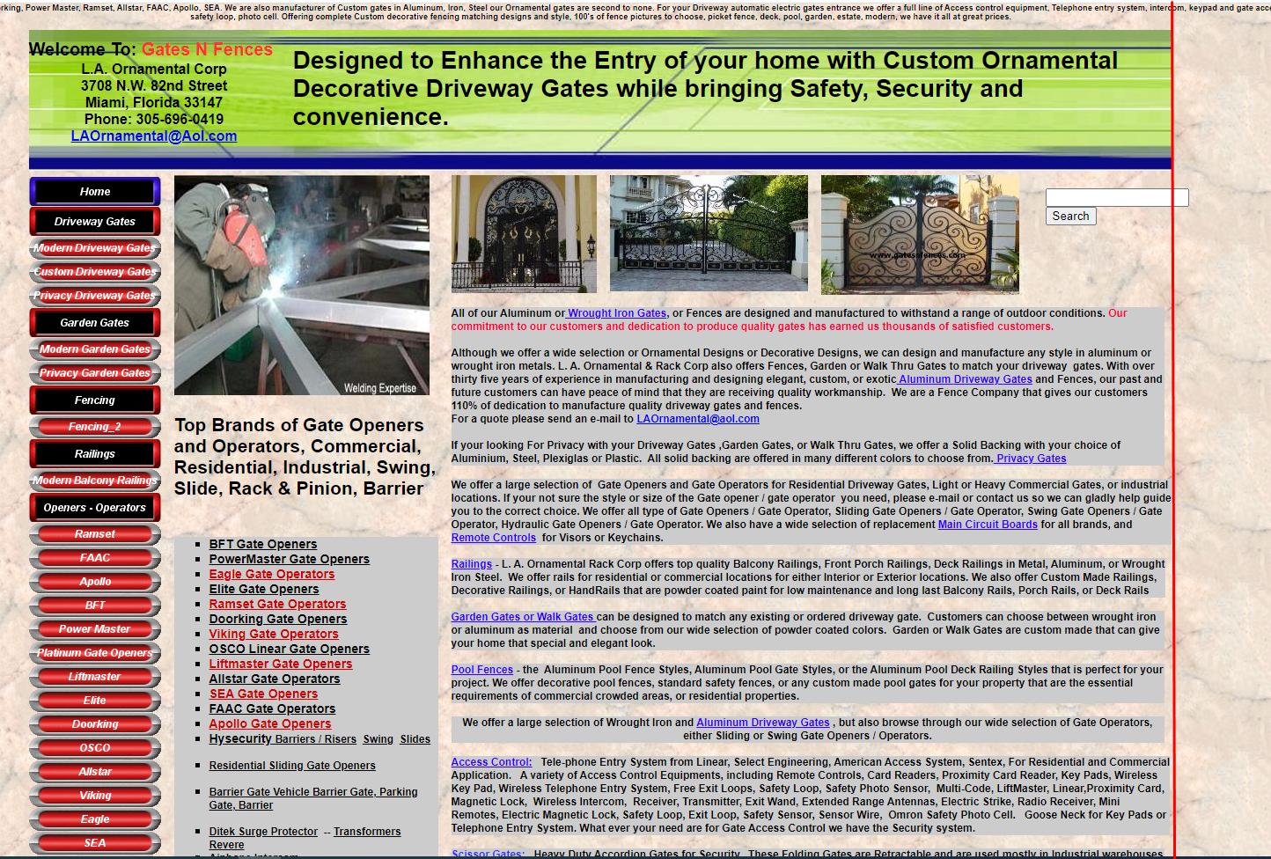

**One hyperlink has multiple <a> tags instead of one**

**Used Device/Browser:**

* Chrome Version 104.0.5112.102 (Official Build) (64-bit) on Windows 10

**Steps to reproduce:**

* Open the <http://www.gatesnfences.com/index.html> page
* Check highlighted hyperlinks as shown on screenshot below
* Hyperlinks function as one link but every word is separate hyperlink leading to the same page which can be seen by inspecting the element

**Screenshot:**

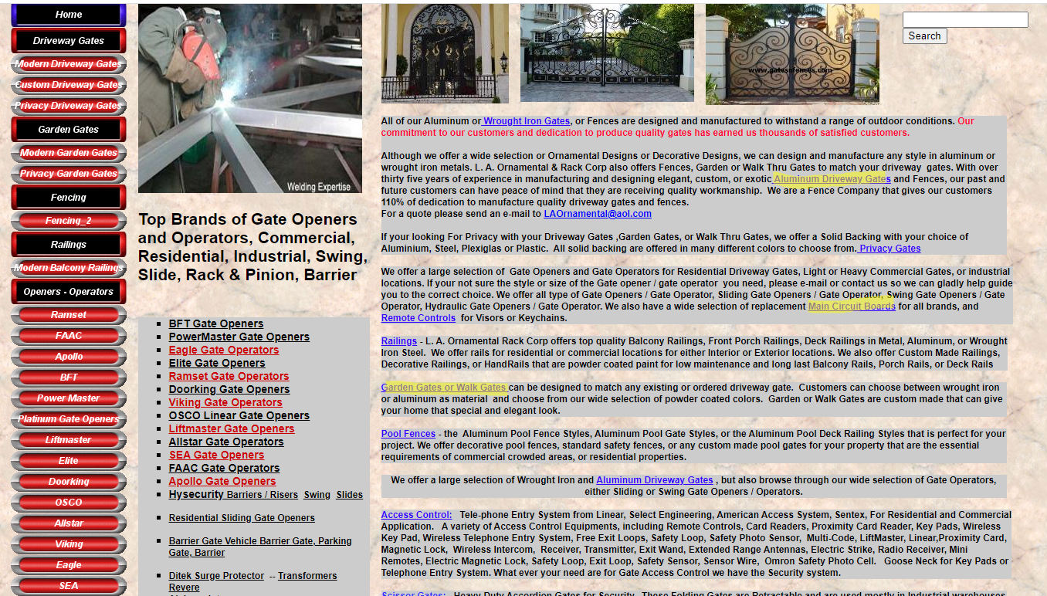

**Bad alignment of elements, not centered within the content wrapper**

**Used Device/Browser:**

* Chrome Version 104.0.5112.102 (Official Build) (64-bit) on Windows 10

**Steps to reproduce:**

* Open the [http://www.gatesnfences.com/Gate\_Access\_Control\_Accesories/Cantilever-Truck-Assembly-Wheels.html](http://www.gatesnfences.com/Gate_Access_Control_Accesories/Cantilever-Truck-Assembly-Wheels.html%20) page
* Scroll down to products at the end of the page
* Check the bad alignment of elements which are not correctly aligned and centered with the content wrapper

**Screenshot:**

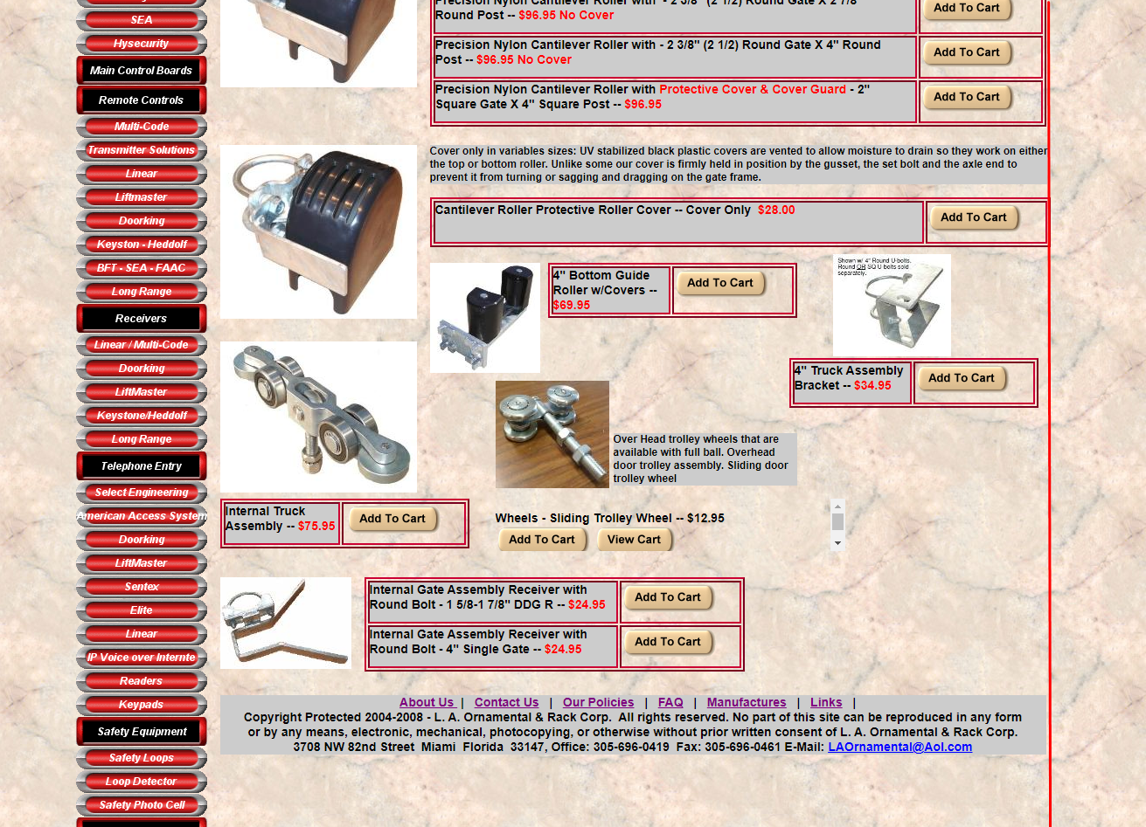

**Vertical scroll on one element**

**Used Device/Browser:**

* Chrome Version 104.0.5112.102 (Official Build) (64-bit) on Windows 10

**Steps to reproduce:**

* Open the [http://www.gatesnfences.com/Gate\_Access\_Control\_Accesories/Cantilever-Truck-Assembly-Wheels.html](http://www.gatesnfences.com/Gate_Access_Control_Accesories/Cantilever-Truck-Assembly-Wheels.html%20) page
* Scroll down to products at the end of the page
* Circled red is element with unnecessary vertical scroll bar

**Screenshot:**

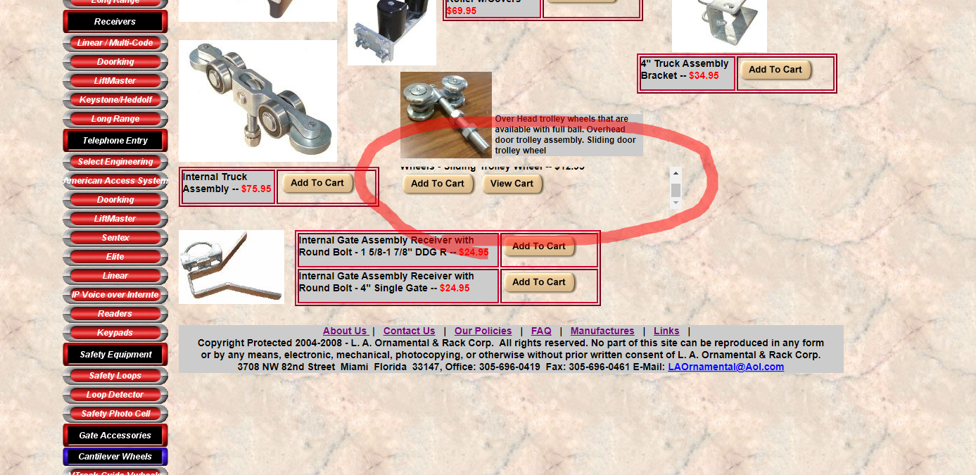

**Checkbox for yes/no question**

**Used Device/Browser:**

* Chrome Version 104.0.5112.102 (Official Build) (64-bit) on Windows 10

**Steps to reproduce:**

* Open the <http://www.gatesnfences.com/contact_us.htm> page
* Click on multiple checkboxes for same question
* Multiple answers allowed on yes/no/don’t know question (should use radio button)

**Screenshot:**

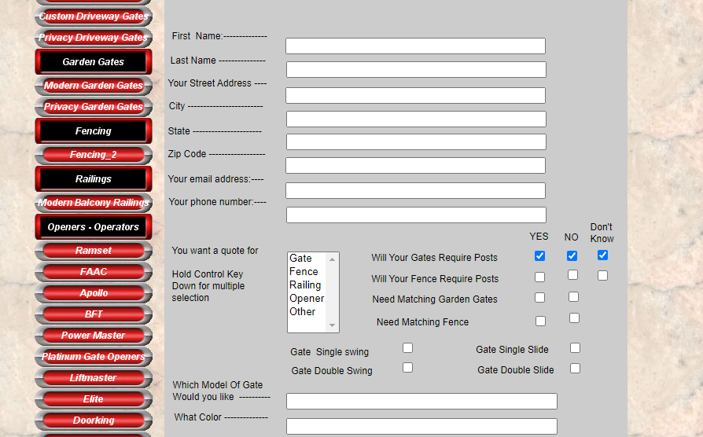

**Unknown/unused input field**

**Used Device/Browser:**

* Chrome Version 104.0.5112.102 (Official Build) (64-bit) on Windows 10

**Steps to reproduce:**

* Open the <http://www.gatesnfences.com/contact_us.htm> page
* Scroll to the middle of the form
* As shown circled yellow on screenshot below you will see an input field without description (inspecting the element shows the name is ‘width of gate’)

**Screenshot:**

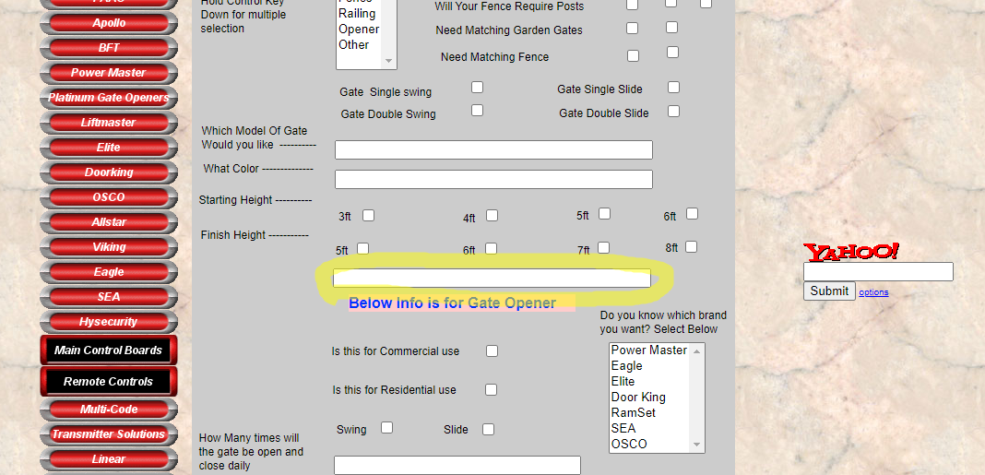

**Text area in form resizeable**

**Used Device/Browser:**

* Chrome Version 104.0.5112.102 (Official Build) (64-bit) on Windows 10

**Steps to reproduce:**

* Open the <http://www.gatesnfences.com/contact_us.htm> page
* Scroll to the bottom of the form
* Click and hold bottom right corner of text area and drag, resize text area which brakes the alignment of the form

**Screenshot:**

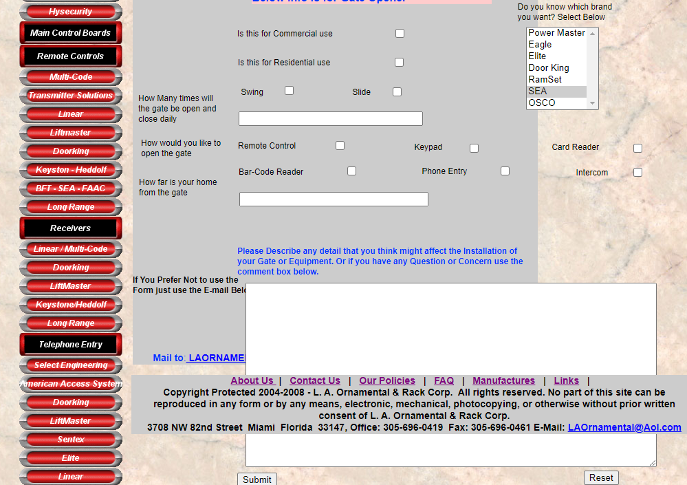

**Form falls out of content wrapper & not aligned**

**Used Device/Browser:**

* Chrome Version 104.0.5112.102 (Official Build) (64-bit) on Windows 10

**Steps to reproduce:**

* Open the <www.gatesnfences.com/ssl/Secure_Script_Registration_Form.html> page
* See form which is not aligned properly and input fields fall out of the content wrapper

**Screenshot:**

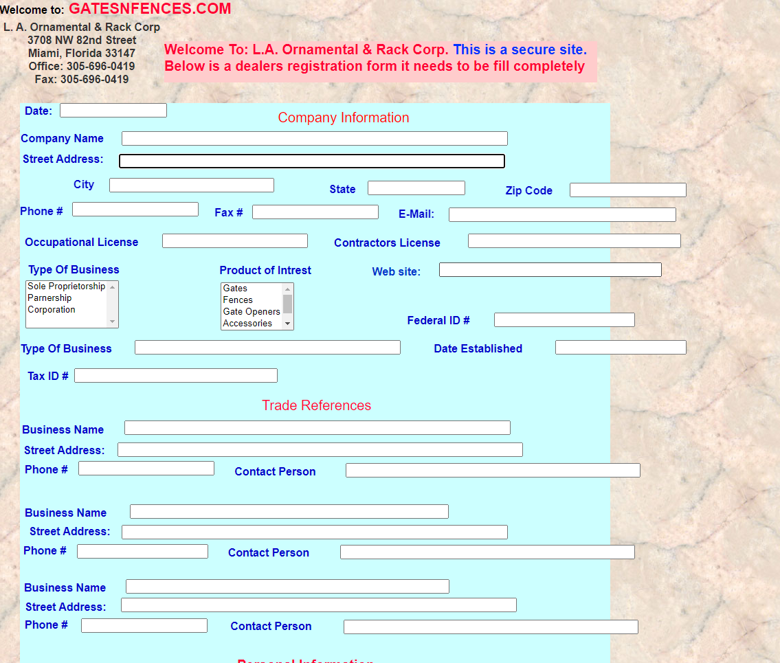

**Dealers application form showing error message stating that the form is not secure**

**Used Device/Browser:**

* Chrome Version 104.0.5112.102 (Official Build) (64-bit) on Windows 10

**Steps to reproduce:**

* Open the <www.gatesnfences.com/ssl/Secure_Script_Registration_Form.html> page
* Click on any of the input fields
* Error message appears stating that the form is not secure

**Screenshot:**

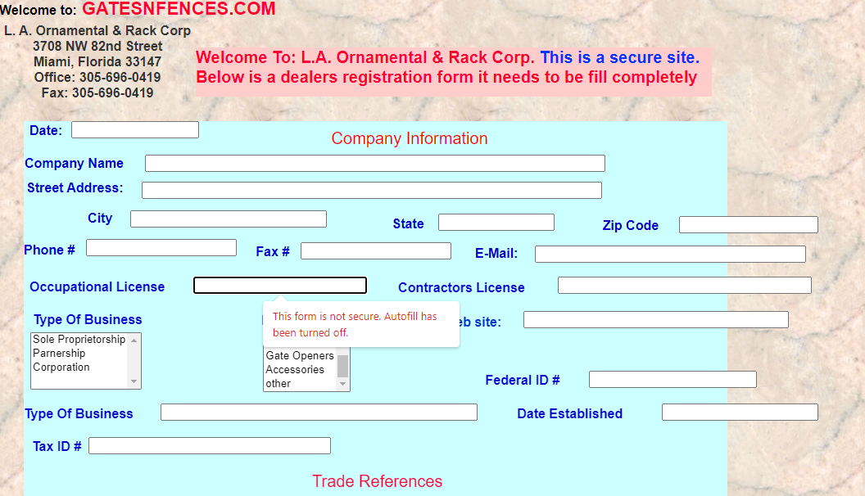

**Overlapping content over text**

**Used Device/Browser:**

* Chrome Version 104.0.5112.102 (Official Build) (64-bit) on Windows 10

**Steps to reproduce:**

* Open the <http://www.gatesnfences.com/About_us.html> page
* See that text is under the content, checking in inspect element, we can see that the text begins in the top left corner, under the content (as seen in screenshot of the issue)

**Screenshot:**

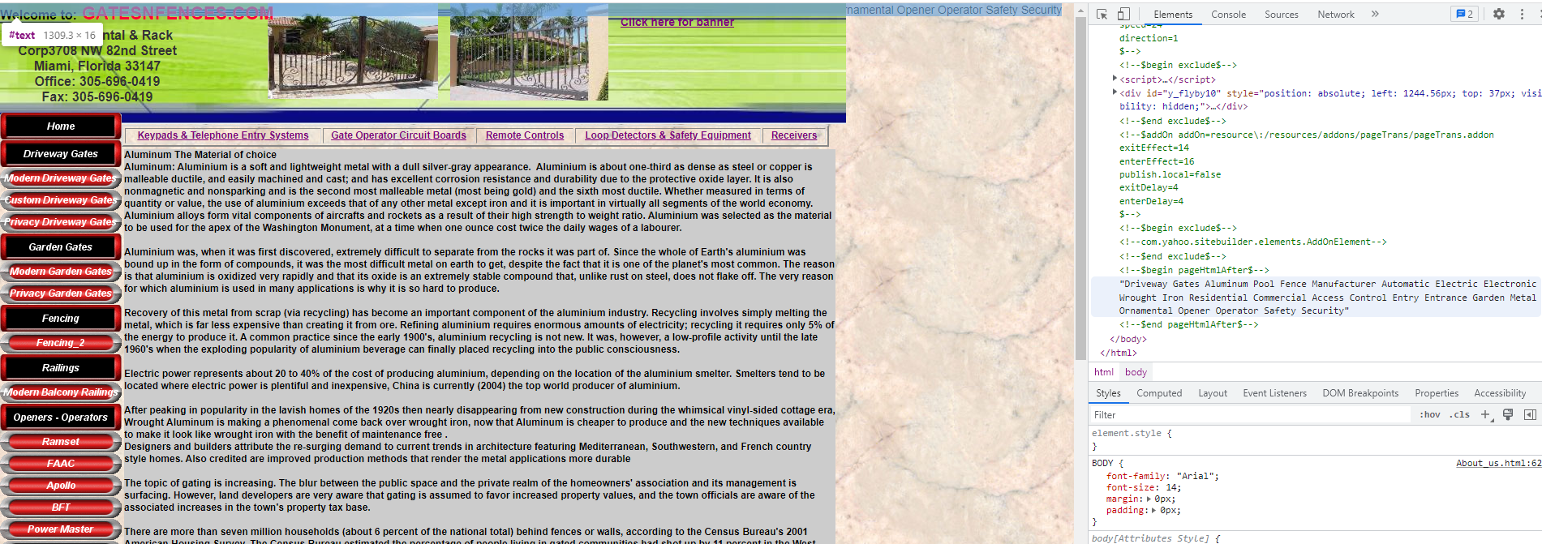

**Content aligned to left**

**Used Device/Browser:**

* Chrome Version 104.0.5112.102 (Official Build) (64-bit) on Windows 10

**Steps to reproduce:**

* Open the <http://www.gatesnfences.com/About_us.html> page
* See that the content is aligned to the left, with no left margin

**Screenshot:**

